Instructions for Out of Office/Vacation e-mail message.

Please open a web-browser, such as Internet Explorer, Netscape or Mozilla.
Type in http://mail.gileschemical.com into the address bar and click <Enter>.

After the site opens, login with your username and password (let me know, if you need yours), and click <Enter>.
The main webmail window will open, click on <Configuration> 3rd from bottom in list on left hand side.
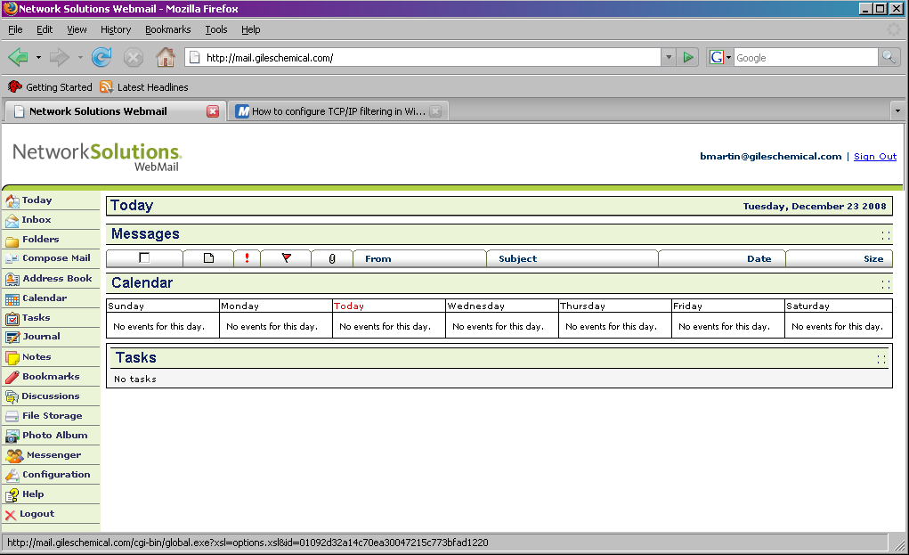

The Options window will open, click on Auto-Responder link in the 3rd column at the top of the list.
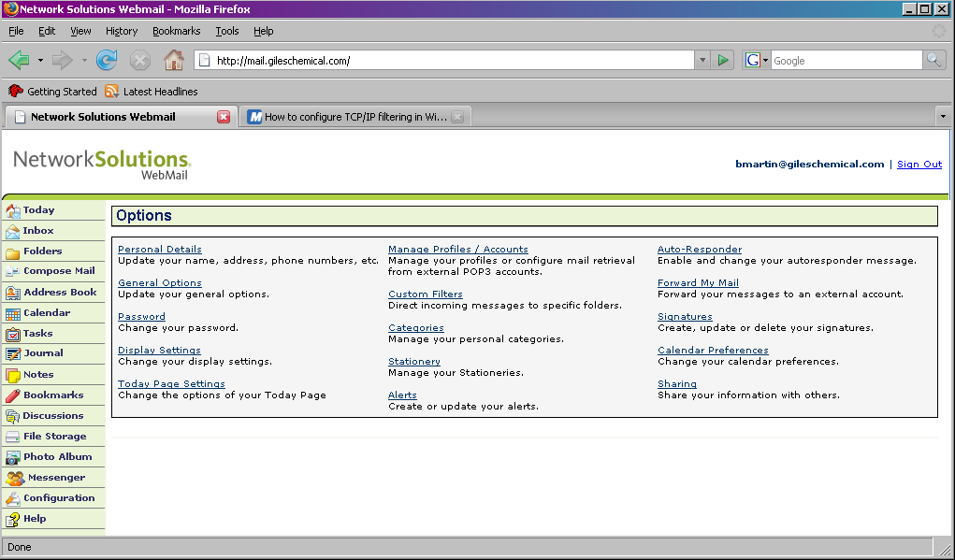

The Auto-Responder Options window will open, type in a Subject, type your out of office reply in Text,
and be sure to click (place a check) in the box, to Enable it. Similarly, Uncheck this box to stop/disable it.
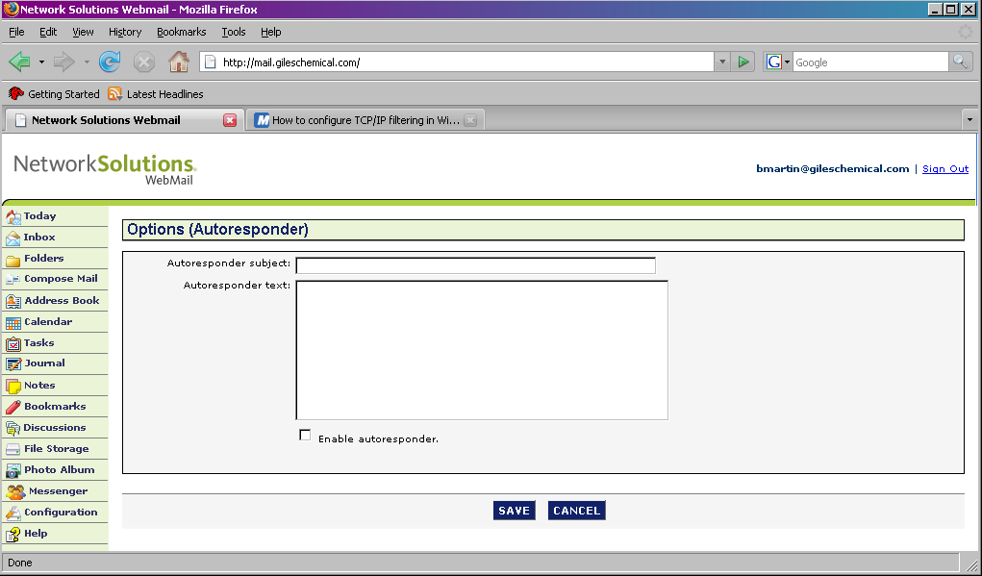
Your Out of Office/Vacation message is now set-up. Enjoy your vacation!

